**TECHNICAL FORM**

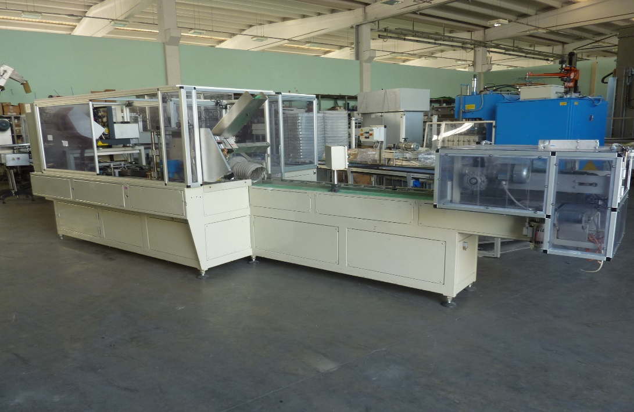

|  |  |
| --- | --- |
| **CARTONING MACHINE  OMV 910/203** | **STC 22 06 028** |
|  |
|  |
|  |  |  |
| Year of construction | 2008 |  |
| Max speed | 100 cp/min |  |
| Min product depth | 113 mm |  |
| Max prductdepth | 130 mm |  |
| Min product width | 60 mm |  |
| Max product width | 62 mm |  |
| Min product height | 36 mm |  |
| Max product height | 38 mm |  |
| Working surface height | 850 mm (out) - 880 mm (in) |  |
| Machine dimensions | 7.830 mm x 2.200 mm x h 2.155 mm |  |
| Power supply | 400 V - 3 PH - 50 HZ |  |
| Power supply | 9 Kw |  |
| Pressure | 6 bar |  |
| PLC | Siemens S7 300 |  |
| HMI | Not present |  |
| Machine condition | Excellent condition |  |
| Warranty | 12 months, only in case of revision ( optional) |  |
| Where to audit | Teampack S.r.l showroom |  |